# **Database/Circuit Design**

* Avatansh Avasthi [1947208]
* Neil D’Souza [ 1947217]
* Prakhar M P [ 1947250]

**USE CASE - DIAGRAM**

Use case diagram is a depiction of the interactions between the user, doctor, hospital and pharmacy of the Android Application. It shows how the various elements are connected and how the app will function. The major elements are users, doctors, hospitals, pharmacies.

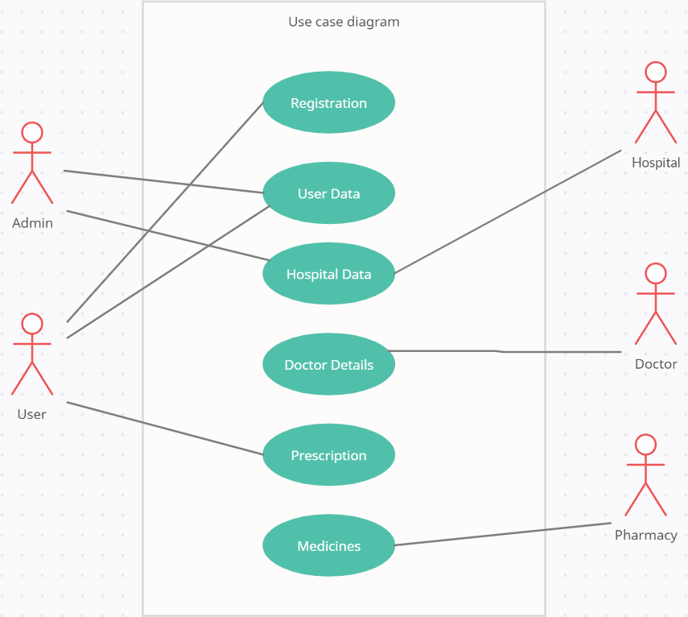

**ER - DIAGRAM**

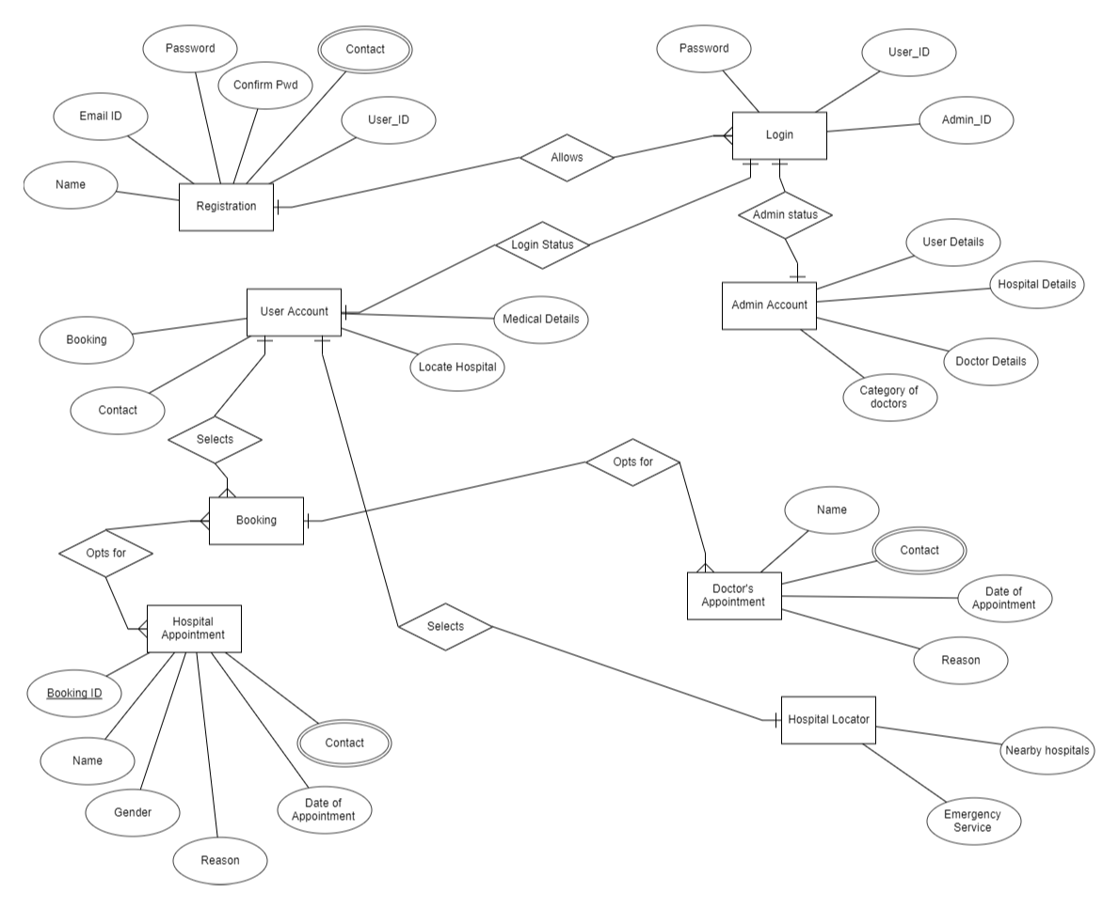

This ER-Diagram represents the model of Medicare Android Application. The entity relationship diagram of Medicare Android Application shows all the visual instruments of database tables and relations between User, Hospital, Doctor, Pharmacy.

**DFD DIAGRAM**

**DFD - 0**

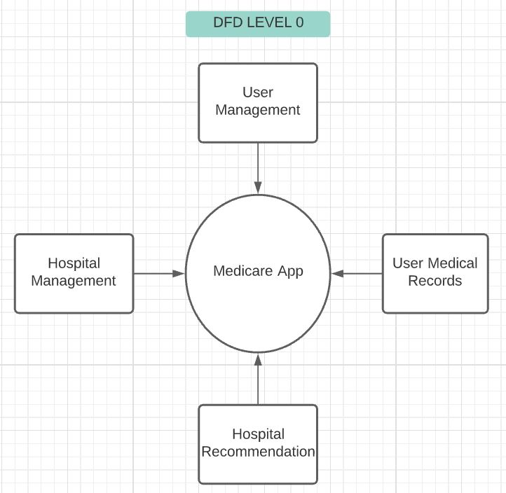

**DFD - 1**

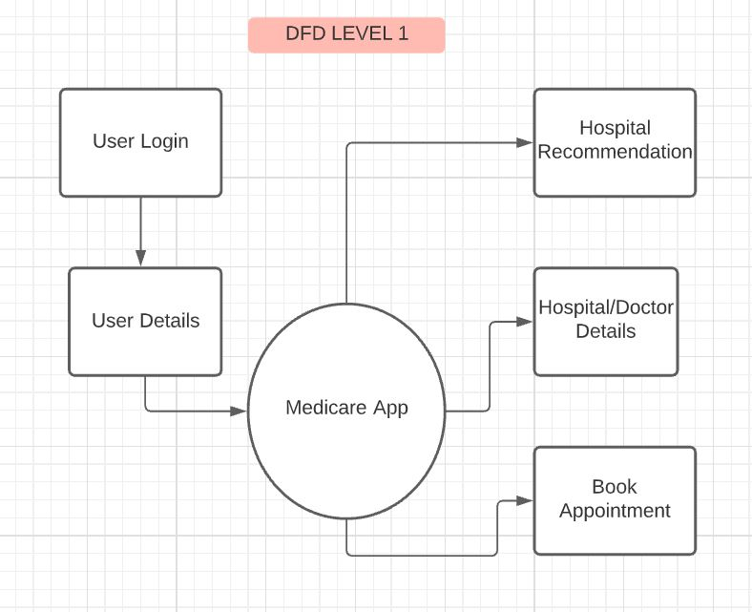

**DFD - 2**

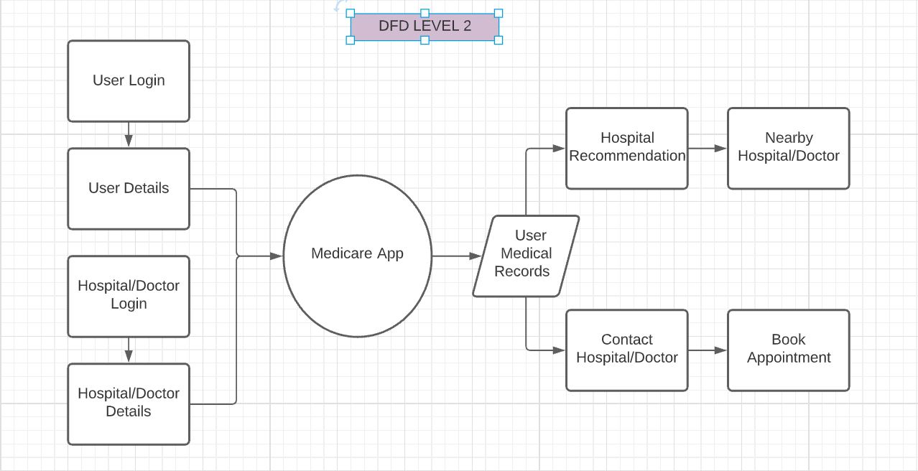

**Class Diagram**

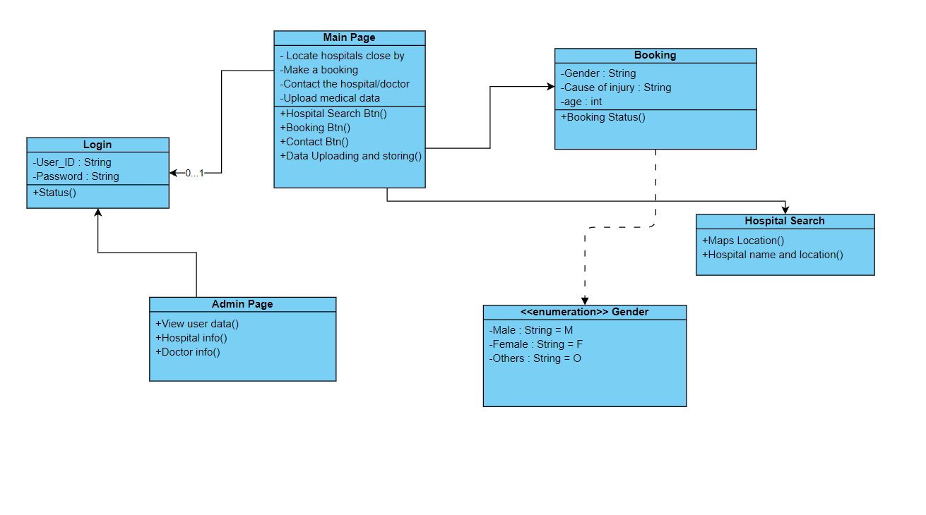

Medicare Android Application Class Diagram describes the structure of classes, their attributes, operations, and the relationships among objects. The main classes of the android app are User, Hospital, Doctor and pharmacy.

**Functional Hierarchy**

